3-Week Mood, Sleep & Function Dashboard

Clinical Summary
Over the past three weeks, the patient demonstrates sustained mood stability without evidence of hypomania or depressive relapse. Sleep consolidation improved following addition of magnesium glycinate (350 mg nightly), with wearable data showing sleep onset improving from approximately 60–90 minutes to ~20 minutes on average. Overall sleep score improved from ~75 to ~90. Anxiety symptoms show progressive reduction. Functional capacity improved alongside structured circadian meal timing and consistent exercise. Social engagement increased with resolution of prior avoidance behaviors. Husband and trainer both report clear functional improvement. No clinical signs of activation or decreased need for sleep observed.

Metabolic & Lifestyle Adjustment
Initial strict metabolic diet produced electrolyte imbalance and was subsequently adjusted. Current diet remains metabolically structured with improved sustainability and electrolyte balance, emphasizing protein, vegetables, healthy fats, limited refined carbohydrates, and circadian-aligned meal timing.

Sleep Duration Trend
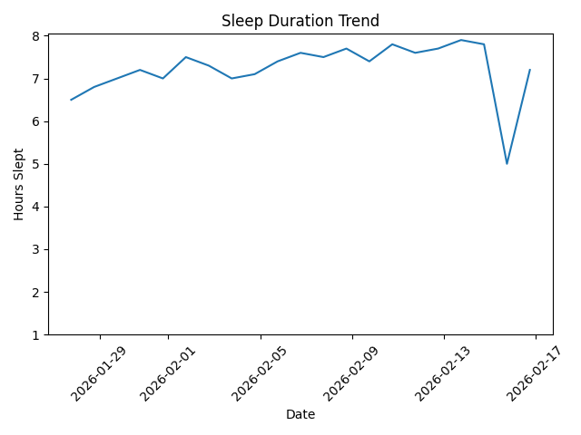

Mood Stability Trend
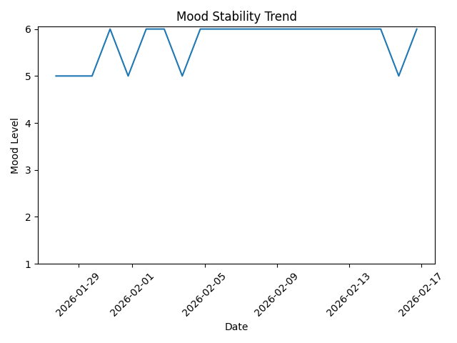

Energy Trend
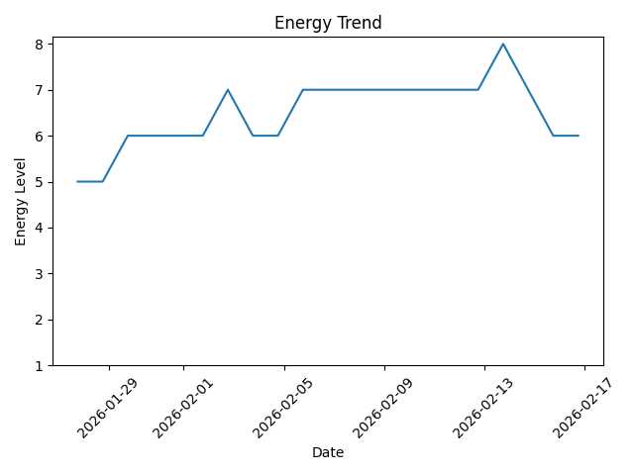

Anxiety Trend
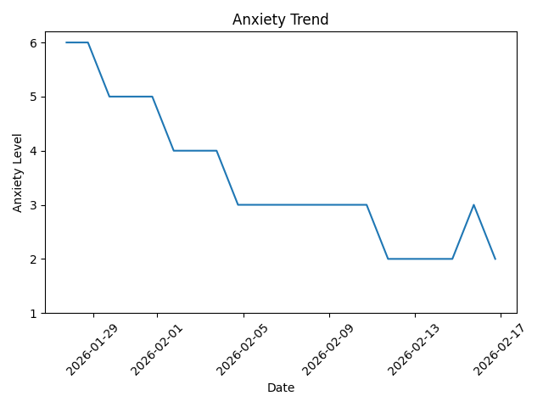

Clinical Literature Context
Observed improvements align with literature showing benefits of sleep stabilization, circadian alignment, exercise, and metabolic interventions in mood disorders. Magnesium supplementation has documented associations with improved sleep and anxiety regulation.

AI Models Used
Trend analysis and reporting were assisted by OpenAI GPT-series reasoning models providing structured data analysis and therapeutic conversational support. These systems assist but do not replace medical decision-making.
Therapeutic conversational support and behavioral pattern analysis were assisted by OpenAI GPT-5 and GPT-4 class large language models used for structured dialogue, adherence support, and clinical summary synthesis. These systems support, but do not replace, clinical decision-making.

Footnote
Data sources include daily self-reports, spouse observations, trainer and coach feedback, and wearable device measurements. This document is intended for clinical progress discussion.
CLIP Technical Architecture Overview
Conceptual Architecture

↓
 !"##$%&$"
↓
'(  )""##
↓
'''*+,'*-*".####
#/0/1!#"#!2#
↓
(' #"!#"/###
.#
↓
("#"##"#"#*0!
Key Technical Insight
##3#"0#"####0/1
#!####2!!"/1#!#
"#""#!3
Why CLIP Works Dierently Than Standard Chat
""#1#4  #$3→ →
#4 5/1" ""!!# ##→ → →
## ##/ !"!!!3→ →
/!##"."#$%&$#!"!##//#
.##3
Future Technical Extensions
##)1##"!4
6#02#"/#
65/17/.0"%#
6!"1!#!#1##
6%"##$##"
CLIP Technical Architecture Overview
Conceptual Architecture

↓
 !"##$%&$"
↓
'(  )""##
↓
'''*+,'*-*".####
#/0/1!#"#!2#
↓
(' #"!#"/###
.#
↓
("#"##"#"#*0!
Key Technical Insight
##3#"0#"####0/1
#!####2!!"/1#!#
"#""#!3
Why CLIP Works Dierently Than Standard Chat
""#1#4  #$3→ →
#4 5/1" ""!!# ##→ → →
## ##/ !"!!!3→ →
/!##"."#$%&$#!"!##//#
.##3
Future Technical Extensions
##)1##"!4
6#02#"/#
65/17/.0"%#
6!"1!#!#1##
6%"##$##"
CLIP Technical Architecture Overview
Conceptual Architecture

↓
 !"##$%&$"
↓
'(  )""##
↓
'''*+,'*-*".####
#/0/1!#"#!2#
↓
(' #"!#"/###
.#
↓
("#"##"#"#*0!
Key Technical Insight
##3#"0#"####0/1
#!####2!!"/1#!#
"#""#!3
Why CLIP Works Dierently Than Standard Chat
""#1#4  #$3→ →
#4 5/1" ""!!# ##→ → →
## ##/ !"!!!3→ →
/!##"."#$%&$#!"!##//#
.##3
Future Technical Extensions
##)1##"!4
6#02#"/#
65/17/.0"%#
6!"1!#!#1##
6%"##$##"

CLIP Technical Architecture Overview

Conceptual Architecture
USER INPUT (daily reports, symptoms, goals)
↓
PROTOCOL & PROMPT LAYER (rules, constraints, workflow, triage logic)
↓
LONGITUDINAL MEMORY LAYER (sleep, mood, diet, exercise, medication responses)
↓
LLM REASONING ENGINE (GPT-5 / GPT-4-class models performing reasoning, pattern synthesis, behavioral guidance, and summarization)
↓
TOOL & DATA PROCESSING LAYER (trend computation, chart generation, reporting, formatting)
↓
STRUCTURED OUTPUT (triage, action recommendations, clinician-readable summaries)

Key Technical Insight
CLIP does not retrain models. Instead, it combines protocol engineering, persistent behavioral data, large language model reasoning, and standardized outputs to achieve longitudinal clinical decision support.

Why CLIP Works Differently Than Standard Chat
Typical conversational systems operate as: User → Model → Answer.
CLIP instead operates as: User → Behavioral Protocol → Memory Accumulation → Reasoning Engine → Trend Synthesis → Structured Output.
Thus, intelligence emerges from disciplined workflow and structured reasoning rather than from a single model response.

Future Technical Extensions
Potential next development layers include:
• Patient stabilization state machine
• Behavior–physiology feedback modeling
• Automatic versus manual intervention modes
• Risk escalation and early warning logic

CLIP Technical Architecture Overview

Conceptual Architecture
USER INPUT (daily reports, symptoms, goals)
↓
PROTOCOL & PROMPT LAYER (rules, constraints, workflow, triage logic)
↓
LONGITUDINAL MEMORY LAYER (sleep, mood, diet, exercise, medication responses)
↓
LLM REASONING ENGINE (GPT‑5 / GPT‑4‑class models performing reasoning, pattern synthesis, behavioral guidance, and summarization)
↓
TOOL & DATA PROCESSING LAYER (trend computation, chart generation, reporting, formatting)
↓
STRUCTURED OUTPUT (triage, action recommendations, clinician‑readable summaries)

Key Technical Insight
CLIP does not retrain models. Instead, it combines protocol engineering, persistent behavioral data, large language model reasoning, and standardized outputs to achieve longitudinal clinical decision support.

Why CLIP Works Differently Than Standard Chat
Typical conversational systems operate as: User → Model → Answer.
CLIP instead operates as: User → Behavioral Protocol → Memory Accumulation → Reasoning Engine → Trend Synthesis → Structured Output.
Thus, intelligence emerges from disciplined workflow and structured reasoning rather than from a single model response.

Future Technical Extensions
Potential next development layers include:
• Patient stabilization state machine
• Behavior–physiology feedback modeling
• Automatic versus manual intervention modes
• Risk escalation and early warning logic

CLIP Automatic Mode – Stabilization & Intervention Architecture

1. State Machine for Patient Stabilization
A patient stabilization system can be modeled as a finite-state machine tracking recovery and stability phases.
Core states include:
• Acute instability – disrupted sleep, mood volatility, poor routine adherence.
• Early stabilization – sleep and routines begin normalizing; mood fluctuations decrease.
• Stable functioning – predictable sleep cycles, stable mood, and consistent routine.
• Recovery optimization – physical conditioning and social engagement increase while stability is maintained.
• Relapse risk – early warning signs such as sleep erosion, behavioral drift, or stress overload appear.
Transitions between states are triggered by sleep trends, mood drift, adherence decline, physiological changes, or stress events. The system goal is early detection and intervention before relapse occurs.

2. Behavior → Physiology Feedback Loop
CLIP models a feedback loop linking behavior and physiology:
Behavior → Physiological change → Subjective state → Behavior adaptation.
Examples include:
• Sleep: late stimulation delays sleep onset, causing fatigue and mood decline the following day.
• Diet: irregular meal timing produces energy swings leading to irritability or anxiety.
• Exercise: consistent activity improves sleep and mood, reinforcing adherence.
The system objective is to reinforce positive feedback loops and interrupt negative ones early.

3. Automatic vs Manual Intervention Modes
Manual mode represents traditional interaction where the user provides updates and requests guidance, and the system responds reactively.
Automatic mode continuously monitors trends and proactively triggers corrective actions, such as bedtime corrections, stimulation reduction, nutrition adjustments, or routine tightening when destabilization risk appears.
Manual override remains available so the user or clinician can adjust decisions.

4. Risk Escalation Logic
A layered escalation model prevents sudden relapse by responding proportionally to risk signals.
• Level 0 – Stable: routine monitoring only.
• Level 1 – Early deviation: small sleep or mood drift corrected via minor routine adjustments.
• Level 2 – Destabilization risk: persistent disruptions trigger structured routine tightening and possible support contact.
• Level 3 – High risk: major warning signs prompt physician contact, medication review, or crisis prevention actions.
This layered escalation ensures interventions occur early while preserving autonomy during stable periods.

System Insight
CLIP functions as a closed-loop behavioral control system combining state tracking, feedback modeling, adaptive intervention, and escalation safeguards to maintain patient stability over time.

